**Strip concrete:**

Strip concrete or strip footing is a continuous strip of concrete that serves to spread the weight of a load-bearing wall across an area of soil. It is the component of a shallow foundation. Strip concrete carrying direct vertical loads, might be designed either in plain concrete or in reinforced concrete. Since strip concrete deflects essentially in one way, it is analyzed by considering as a strip of unit width and length.

Quantity of strip concrete at the site: 85.079583 Cu m

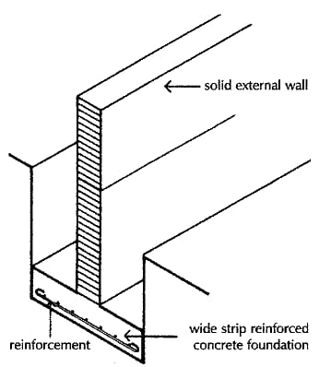

Strip concrete